DIGITAL SYSTEMS
EXERCISES 1
*Note: Kí hiệu ~ sẽ được thay thế cho dấu đảo (vd :~A =$\underline{A}$)
- Simplify the following expressions using Boolean Algebra
  - $f=ABC+ \underline{A}C=C\left(AB+\sim A\right)=C\left(B+\sim A\right)=CB+C\sim A$
  - $h=(Q+R)(\underline{Q}+\underline{R})=Q\sim Q+R\sim Q+Q\sim R+R\sim R=R\sim Q+Q\sim R$
  - $p=ABC+A\underline{B}C+\underline{A}= AC\left(B+\sim B\right)+\sim A=AC+\sim A=\sim A+C$
  - $q=\underline{RST}(\underline{R+S+T})=\left(\sim R+\sim S+\sim T\right)\sim R\sim S\sim T=\sim R\sim R\sim S\sim T+\sim S\sim R\sim S\sim T+\sim T\sim R\sim S\sim T=\sim R\sim S\sim T$

  - $w=\underline{A}\underline{B}\underline{C}+\underline{A}BC+ABC+A\underline{B}\underline{C}+A\underline{B}C=\sim B\sim C\left(\sim A+A\right)+BC\left(\sim A+A\right)+A\sim BC=\sim B\sim C+BC+A\sim BC=\sim B\sim C+C\left(B+A\sim B\right)=\sim B\sim C+CB+CA$
  - $x=\left(B+\underline{C}\right)\left(\underline{B}+C\right)+\underline{\underline{A}+B+\underline{C}}=$ BC + AC + ~B~C + A~B
  - $y=\left(\underline{C+D}\right)+ \underline{A}C\underline{D}+A\underline{B}\underline{C}+\underline{A}\underline{B}CD$ = ~C~D+ ~AC~D + A~B~C + ~A~BCD
= ~AC(~D+~BD) + ~C~D + A~B~C = ~AC(~D + ~B) + ~C~D + A~B~C = (~AC~D + ~C~D) + ~AC~B + A~B~C = ~D (~AC + ~C) + ~AC~B + A~B~C
= ~D~A+ ~D~C +~AC~B + A~B~C
  - $z= AB\left(\underline{\underline{C}D}\right)+\underline{A}BD+\underline{B}\underline{C}\underline{D}$
= ABC + AB~D + ~ABD + ~B~C~D
- Simplify the circuits shown in the figures below using Boolean Algebra
  - 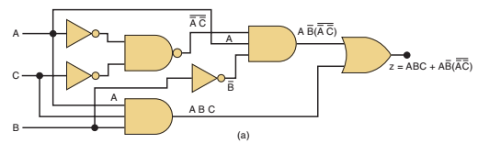
Z = ABC + A~B~(~A~C) = ABC+ A~B(A+C) = ABC +A~BA+A~BC = AC + A~B

  - 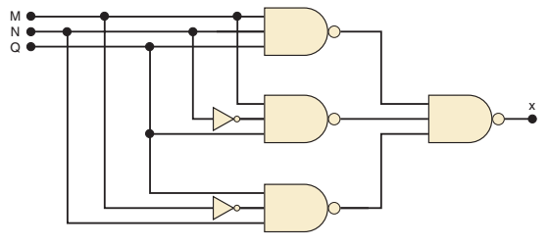
X = ~(~(MNQ)~(M~NQ) ~(~MNQ)) =MNQ + M~NQ + ~MNQ = NQ + M~NQ = Q(N+M~N) = QN + QM
- Use a K-map to simplify (all possible cases)
  - $F\left(A,B,C\right)=∑\left(1,2,3,4,6,7\right)$
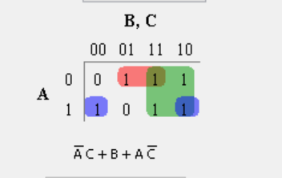
  - $F\left(A,B,C,D\right)=∑\left(1,3,4,5,6,7,12,13\right)$
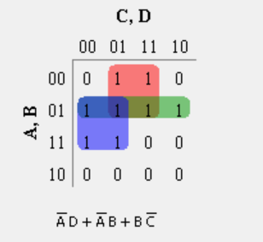
  - $F\left(A,B,C,D\right)=∑\left(2,5,7,8,10,12,13,15\right)$
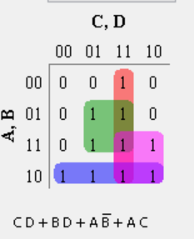
  - $F\left(A,B,C,D\right)=∑\left(0,6,8,9,10,11,13,14,15\right)$
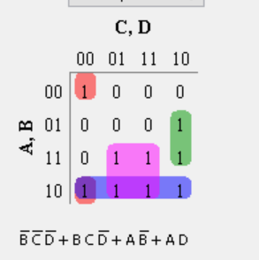
  - $F\left(A,B,C,D\right)=∑\left(0,4,5,6,7,8,9,10,11,13,14,15\right)$
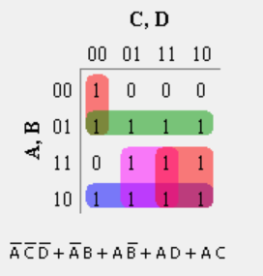
  - $F\left(D,C,B,A\right)=∑\left(0,2,3,5,7,8,10,11,12,13,14,15\right)$
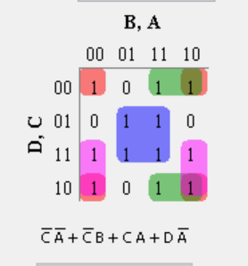
  - $F\left(D,C,B,A\right)=∑\left(0,1,4,5,7,8,10,13,14,15\right)$
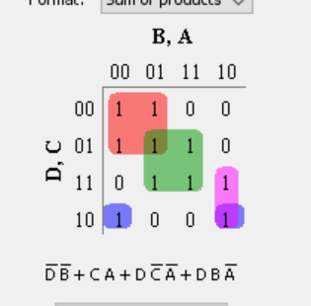
  - $F\left(D,C,B,A\right)=∑\left(1,2,5,10,12\right)+∑d(0,3,4,8,13,14,15)$
ta có các giá trị nằm trong $∑$d(..) được tính là don’t care (x) nên ta có bảng sau:
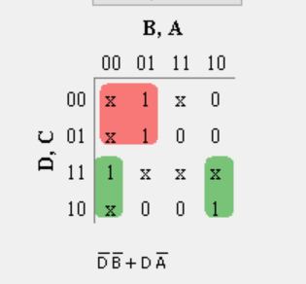
- Use a K-map to simplify (all possible cases)
- $F\left(A,B,C,D\right)=∑m\left(0,1,2,5,7,8,10,14,15\right)+d\left(3,13\right)$
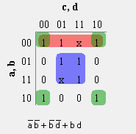
- $F\left(A,B,C,D\right)=\prod{}M\left(1,3,4,5,11,12,14,15\right).D\left(0,6,7,8\right)$
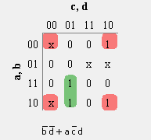
- $F\left(A,B,C,D\right)=∑m\left(1,3,6,8,11,14\right)+d(2,4,5,13,15)$
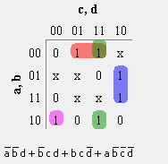
- $F\left(A,B,C,D\right)= \prod{}\left(1,5,6,7,9,11,15\right).D(5,7,10,12)$
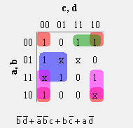
- $F\left(D,C,B,A\right)=∑\left(0,1,4,6,10,14\right)+d(5,7,8,9,11,12,15)$
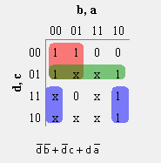

- $F\left(E,D,C,B,A\right)=∑m\left(1,3,10,14,21,26,28,30\right)+d(5,12,17,29)$
- $F\left(A,B,C,D\right)=\prod{}M(0,2,3,4,7,8)$
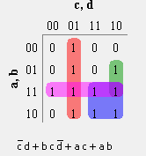

- Design a circuit that produces a HIGH out only when all three inputs are the same level.
  - Use a truth table and K map to produce the SOP solution
True table:
A | B | C | X
0 | 0 | 0 | 1
0 | 0 | 1 | 0
0 | 1 | 0 | 0
0 | 1 | 1 | 0
1 | 0 | 0 | 0
1 | 0 | 1 | 0
1 | 1 | 0 | 0
1 | 1 | 1 | 1
K-MAP
 | 0 | 1
00 | 1 | 0
01 | 0 | 0
11 | 0 | 1
10 | 0 | 0
ABC + ~A~B~C
  - Use two-input XOR and other gates to find a solution.
True table of XOR 2 input gate:

A | B | X (output)
0 | 0 | 0
0 | 1 | 1
1 | 0 | 1
1 | 1 | 0
Ta thấy giá trị ngõ ra của XOR bằng 1 khi và chỉ khi 2 input của nó có mức logic ngược nhau. Vậy để 2 input bằng nhau mà ngõ ra vẫn là 1 thì ta cần thêm một cổng not vào XOR

Với yêu cầu của đề: Ngõ ra đạt mức cao (output =1) khi tất cả 3 input đều chung một mức logic (cùng bằng 0 hoặc cùng bằng 1). Hay ta có thể hiểu rằng khi A = B VÀ B=C thì ngõ ra sẽ đạt mức cao.
(A == B && B == C) => (A == C)
Vậy ta cần sử dụng 2 cổng XOR có not ở đầu và 1 cổng AND cho biểu thức luận lý này.

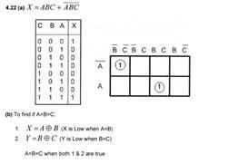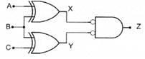
Dùng phép biến đổi tương đương ta có thể biến cổng Bubble AND thành cổng NOR:
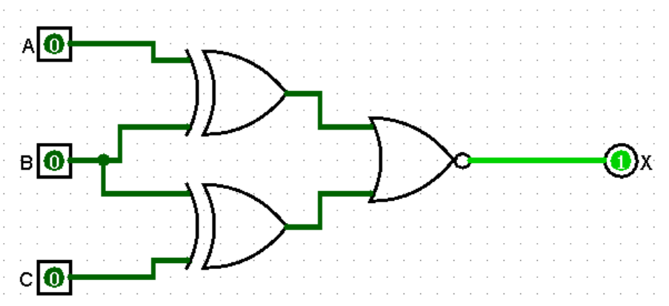
- The following function is in minimum sum of products form. Implement it using only two-input NAND gates. No gate may be used as a NOT
  - $K=\underline{A }\underline{B }X+A\underline{B }\underline{X }+\underline{A}B\underline{X }+ABX$
K = $\left(A^{'}B^{'}+AB\right)X+\left(A^{'}B+AB^{'}\right)X^{'}= ((((A’B’)’(AB)’)’X)’(((AB’)’(A’B)’)’X')’)’$ (12 Gates)

- Construct he given circuit using NAND gates only:
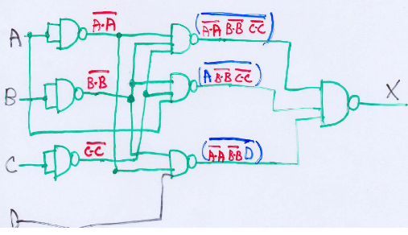
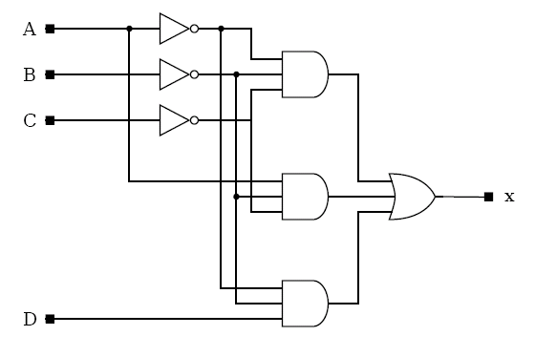
Expanding the Boolean expression
By DeMorgan’s Theorems 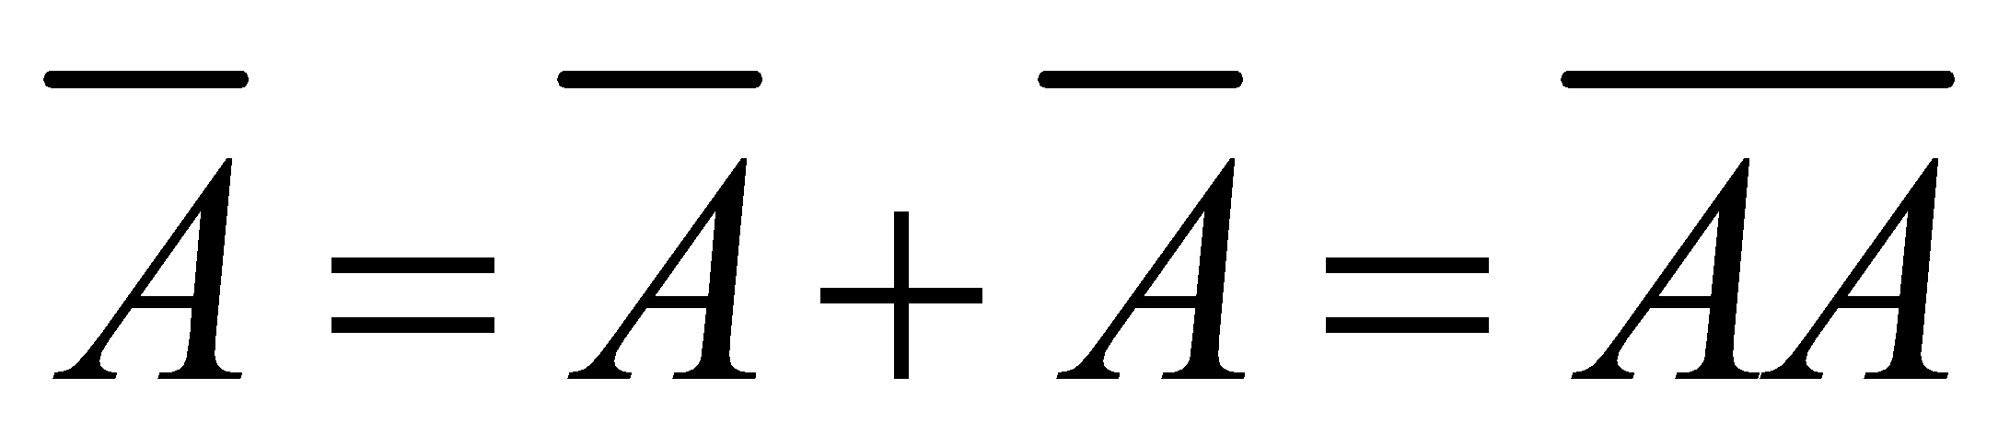
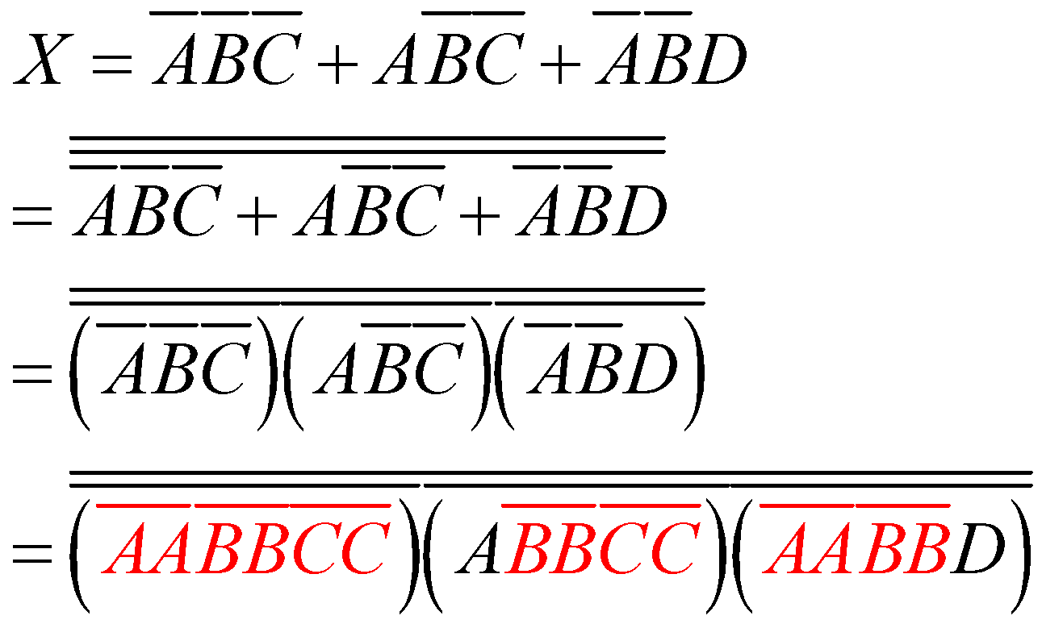
- A manufacturing plant needs to have a horn sound to signal quitting time. The horn should be activated when either of the following conditions is met:
  - It’s after 5 o’clock and all machines are shutdown
  - It’s Friday, the production run for the day is complete, and all machines are shutdown.
Design a logic circuit that will control the horn.

A: Clock Time (1: After 5 o’clock; 0: Before 5 o’clock)
B: Day (1: Friday; 0: Others)
C: Machine Status (1: All machines are shutdown; 0: At least one machine is not shutdown)
D: The production run for the day is complete (1: complete, 0: not complete)
X: Horn Sound (1: activated; 0: deactivated)

Từ đó ý a) sẽ trở thành : Khi A=1 && C =1 thì X (output) sẽ bằng 1. (Input: 1x1x)
b) sẽ trở thành : Khi B =1 && D =1 && C = 1 thì X sẽ bằng 1. (Input: x111)
Ta có bảng trân trị:
A | B | C | D | X
0 | 0 | 0 | 0 | 0
0 | 0 | 0 | 1 | 0
0 | 0 | 1 | 0 | 0
0 | 0 | 1 | 1 | 0
0 | 1 | 0 | 0 | 0
0 | 1 | 0 | 1 | 0
0 | 1 | 1 | 0 | 0
0 | 1 | 1 | 1 | 1
1 | 0 | 0 | 0 | 0
1 | 0 | 0 | 1 | 0
1 | 0 | 1 | 0 | 1
1 | 0 | 1 | 1 | 1
1 | 1 | 0 | 0 | 0
1 | 1 | 0 | 1 | 0
1 | 1 | 1 | 0 | 1
1 | 1 | 1 | 1 | 1

K-MAP:
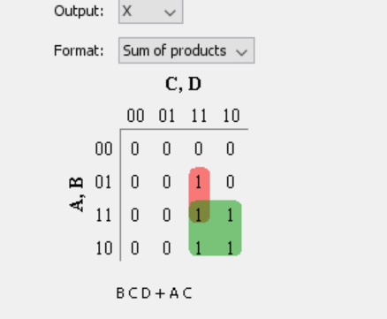
Từ đó biểu thức rút gọn là : AC + BCD
- Figure below shows a diagram for an automobile alarm circuit used to detect certain undesirable conditions. The three switches are used to indicate the status of the door by the driver’s seat, the ignition, and the headlights, respectively. Design the logic circuit with these three switches as inputs so that the alarm will be activated whenever either of the following condition exists:

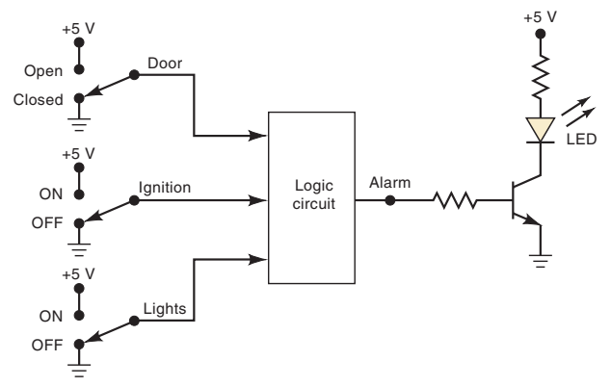
  - The headlights are on while the ignition is off
  - The door is open while the ignition if on

Fisrt step: Think about the conditions that exist for an alarm activation:
- L (lights) ON and I (Ignition) OFF
- D (door) OPEN and I (Ignition) ON
This means that we are looking at two AND conditions and one OR condition, as both should not happen at the same time.
~IL + ID

D | I | L | Alarm
0 | 0 | 0 | 0
0 | 0 | 1 | 1
0 | 1 | 0 | 0
0 | 1 | 1 | 0
1 | 0 | 0 | 0
1 | 0 | 1 | 1
1 | 1 | 0 | 1
1 | 1 | 1 | 1

- ABCD code is being transmitted to a remote receiver. The bits are A₃, A₂, A₁, and A₀, with A₃ as the MSB. The receiver circuitry includes a BCD error detector circuit that examines the received code to see if it is a legal BCD code (i.e., <= 1001). Design this circuit to produce a HIGH for any error condition.

BCD only goes from digit 0 (0000) to digit 9 (1001), so all you’ve got to do is make a function that produces high for numbers from 10 (1010) to 15 (1111) as follows:
A3 | A2 | A1 | A0 | F
0 | 0 | 0 | 0 | 0
0 | 0 | 0 | 1 | 0
0 | 0 | 1 | 0 | 0
0 | 0 | 1 | 1 | 0
0 | 1 | 0 | 0 | 0
0 | 1 | 0 | 1 | 0
0 | 1 | 1 | 0 | 0
0 | 1 | 1 | 1 | 0
1 | 0 | 0 | 0 | 0
1 | 0 | 0 | 1 | 0
1 | 0 | 1 | 0 | 1
1 | 0 | 1 | 1 | 1
1 | 1 | 0 | 0 | 1
1 | 1 | 0 | 1 | 1
1 | 1 | 1 | 0 | 1
1 | 1 | 1 | 1 | 1

F = A3A2 + A3A1

